Practical 11: Student Management System with CRUD Operations
Problem Definition
Implement a Student Management System using PHP and MySQLi. The system should allow adding, viewing, editing, and deleting student records. It should also provide search, filter, and CSV export functionality using a database table.
A. Theory
1. What does CRUD stand for?
Answer: CRUD stands for Create, Read, Update, and Delete. These are the basic operations used to manage database records.
2. Which database is used for student records?
Answer: MySQL is used to store student records, and PHP with MySQLi is used to communicate with the database.
3. What fields are maintained for a student?
Answer: The system maintains student ID, name, email, course, and status.
4. Can student records be searched and filtered?
Answer: Yes. The management page provides search and filter options to find student records easily.

B. Implementation / Output / Result
The Student Management page displays student records in a table.
Create: Add a new student using the Add Student form.
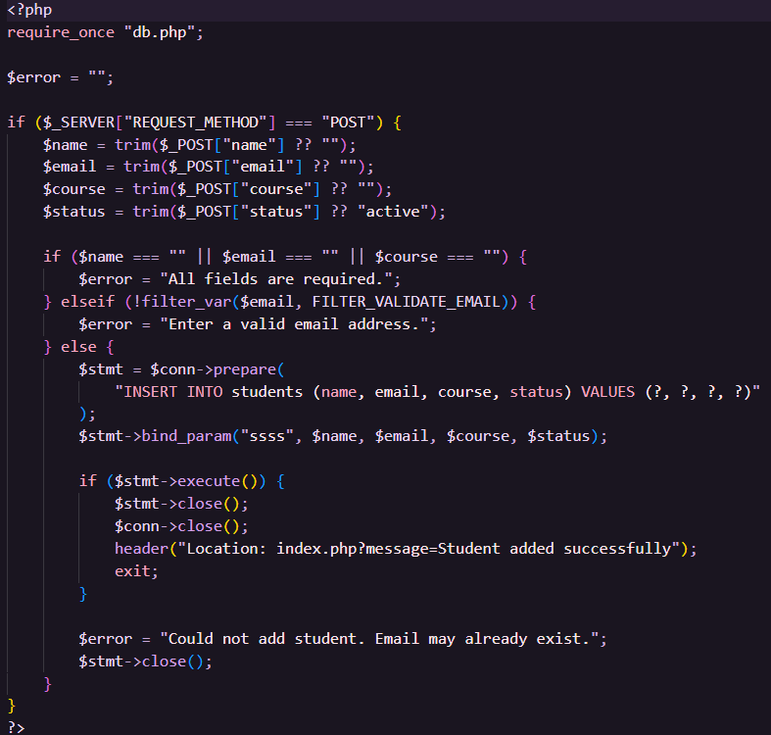

Read: View all stored student records.

Update: Edit an existing student record.
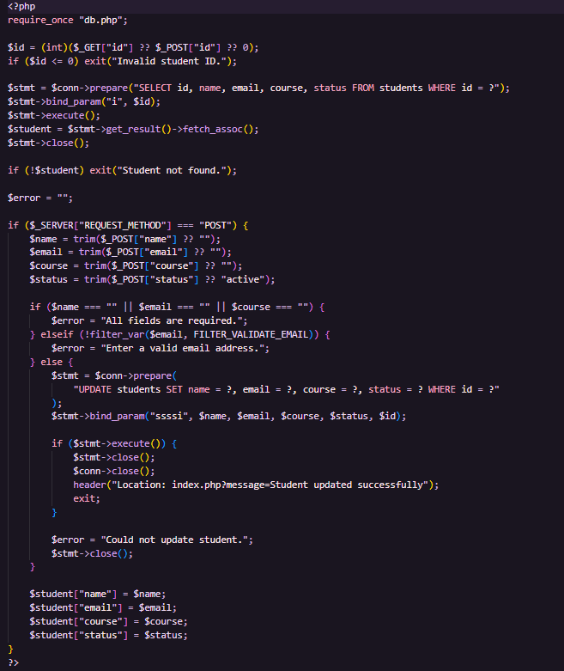
Delete: Remove a student record from the database.
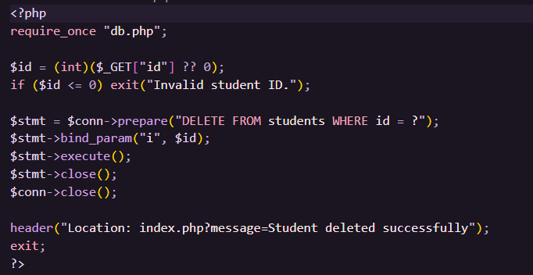
Search and Filter: Find students by relevant details and status.
Export: Export student records as a CSV file.
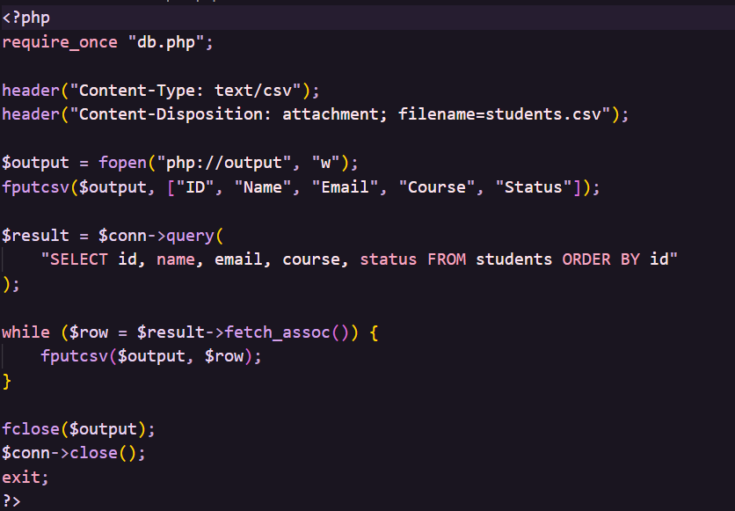
Result: Student records can be managed successfully through the PHP and MySQLi based CRUD system.
C. Evidence of Work (Screenshots)
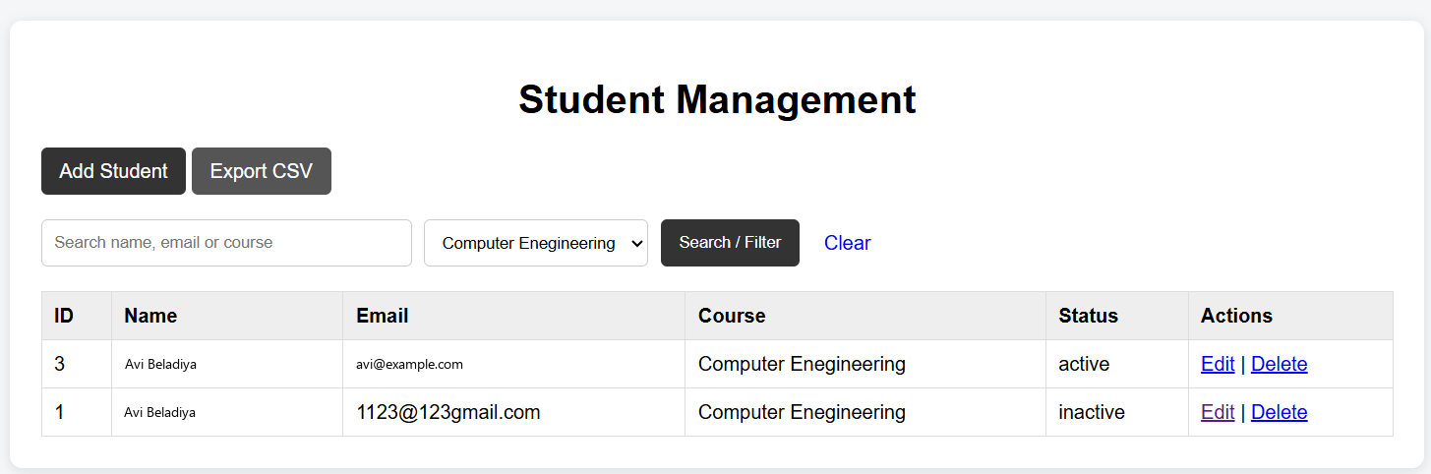
D. GitHub Repository Link
https://github.com/Avi4522/StudentHub/tree/main/Practical-11
E. Challenges Faced
I initially faced an 'Unknown column email in field list' error because the existing students table had a different structure. I fixed it by adding the required missing columns without dropping the table.
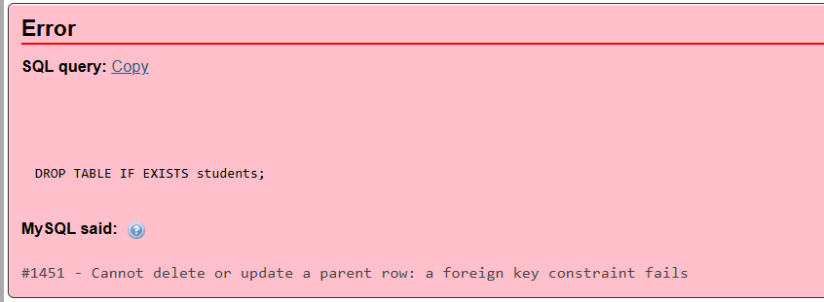
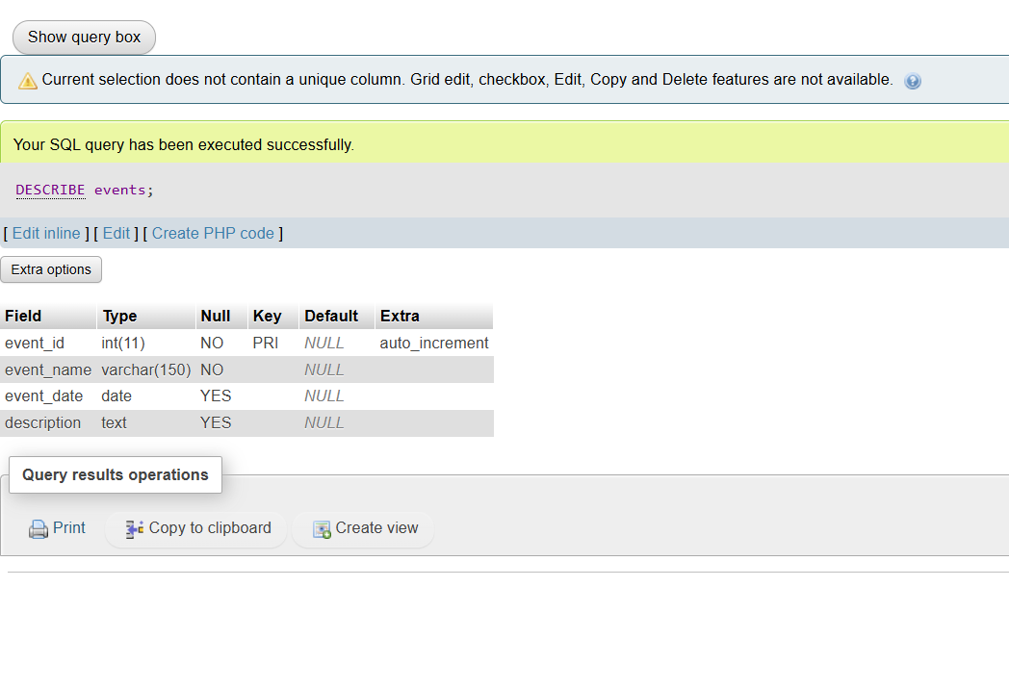F. Learning Outcomes
I learned how to implement CRUD operations using PHP and MySQLi. I also learned database table modification, prepared statements, search and filtering, record deletion, updating records, and CSV export.
Faculty Remarks:

